PD: Ethics in Research Workshop

Speaker: Dr. Anant R. Kukreti
Date: June 21, 2017
Time: 9-10 AM
Venue: University of Cincinnati, Swift Hall, room 516

Prepared by: Molly A. Hamilton, School for Creative and Performing Arts, Cincinnati, Ohio
RET Participant for Project #4 Air Quality Monitoring and Emissions Characterization Near a Major Roadway

This session was given by Dr. Anant Kukreti. Dr. Kukreti is Director for Engineering Outreach for the College of Engineering and Applied Science and Professor in the Department of Biomedical, Chemical and Environmental Engineering. He joined UC in August, 2000, as Head of the Department of Civil and Environmental Engineering (CEE) and before that worked for 22 years at University of Oklahoma, Norman, Oklahoma. After serving as the Department Head of CEE he was appointed as the Associate Dean for Engineering Education and Research in the College of Engineering and Applied Science in which capacity he served until August 2009. He teaches structural mechanics, with research in steel structures, seismic analysis and design, and engineering education. He has won five major university teaching awards, two Professorships, two national American Society of Engineering Education teaching awards, and is internationally recognized in his primary research field. He has extensive administrative experience in managing major NSF grants, which includes can ongoing $9 Million Math and Science Partnership grant, a $2 Million STEP grant, a $600,000 S-STEM grant, a $300,000 REU grant, and a $500,000 RET grant. He is also coordinating a $4.3 Million Choose Ohio First Scholarship grant from the Ohio Board of Regents.
Dr. Kukreti introduced the PD (Figure 1) as a workshop on ethics, as it is related to research, and that it is required for all RET projects. He asked us when we talk about ethics with our students. Ideas discussed included plagiarism, making up data, treating the specimens in anatomy with respect, and using siblings as test subjects. Due to legal reasons, research ethics needs to be well defined. However, some of it is common sense. A lot of research ethics is descriptive in nature, unable to be quantified, and needs to be judged by a group. There are not always hard and fast rules.
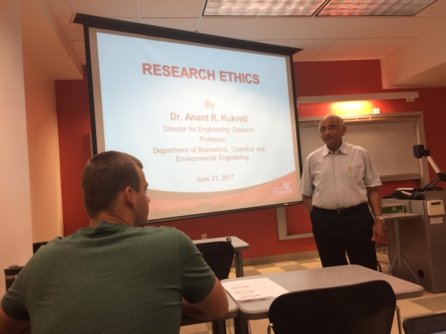
Figure 1: Dr. Kukreti Begins the Ethics Workshop
Four main categories of common sense ethics are: don’t fudge your data, don’t mislead people, don’t take money to get the right answer, and don’t try to profit from your research for personal gains. Recently, some issues and abuses have brought ethics into focus. We have seen unethical and reprehensible experiments on human subject. For example, Nazis conducted experiments on human subjects who didn’t know anything about it. Also, acceptance of gifts or research support in return for “good” results, burying “bad” results, disclosure of unverified results for publicity or to obtain additional funding, purposeful attempts to mislead for political reasons, and people taking selective information to support the side they choose. These have been seen from pharmaceutical companies, soft drink companies, tobacco, the automobile industry, and about climate change. Sometimes, researchers in industry have their hands tied as to when they can let the information out, agreeing not to publish their results for a certain number of years or until a certain date.
Two fundamental issues that are well defined, but not easy to identify are misconduct and unethical behavior. Misconduct occurs when someone knowingly falsifies data or results, has a conflict of interest, or receives some sort of personal gain. Intent is important (Figure 2). It is not considered misconduct if you left data out because you didn’t think it was important, but later you realize it is important. Misconduct is punishable. The group reviewing the misconduct will have to take some action, which could be a legal punishment or job punishment. Unethical behavior involves some violation of usual norms of fairness and integrity. If there is some error, it is better to report it.
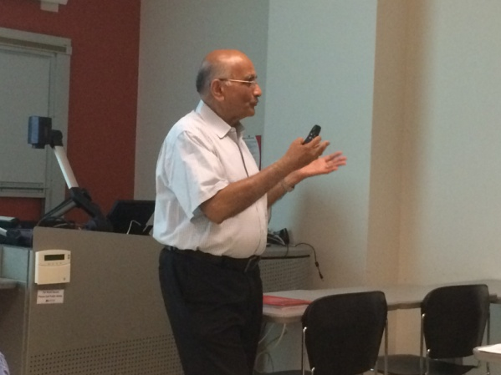
Figure 2: Dr. Kukreti Explains that Intent is Important.
Misconduct and unethical behavior are very general. Resnik worked to establish some more detailed rules for people to follow. He defined these 13 terms (expanded upon by Dr. Kukreti):
- Honesty – Strive for honesty in all scientific communications. Honestly report data, results, methods and procedures, and publication status. Results need to be disseminated as quickly as possible, so write a conference paper with a limited scope, then do more research and write a journal paper. Several conference papers can be combined to make a journal paper. Someone else could be working on similar research. Communicate with each other. The important part is the disclosure. Make that very clear. Example: an electronic device, something erratic happens, and you get weird fluctuations, someone next door may be running a drill. Explain it. Use statistical calculations.
- Objectivity – Strive to avoid bias in experimental design, data analysis, data interpretation, peer review, personnel decisions, grant writing, expert testimony, and other aspects of research where objectivity is expected or required. It is important to disclose personal or financial interests, or bias towards and individual that may affect research. We all have biases, prejudices and preconceived notions. Evaluate research in two important categories to reduce bias: technical merits (advancement, further development of knowledge) and broad impacts (besides that research area, what other way will this fundamental research impact society, will it open up more doors or be used for other areas).
- Integrity – Keep your promises and agreements; act with sincerity; strive for consistency of thought and action.
- Carefulness – Avoid careless errors and negligence; carefully and critically examine your own work and the work of your peers. Keep good records of research activities. Personal journals will help you when you start writing your research.
- Openness – Share data, results, ideas, tools, and resources. Be open to criticism and new ideas. Disseminate new findings as soon as possible, look for possible avenues to publish data.
- Respect intellectual property – Honor patents, copyrights, and other forms of intellectual property. If you use someone else’s work, make sure you site it. Never plagiarize.
- Confidentiality – Protect confidential communications, such as papers or grants submitted for publication, personnel records, trade or military secrets, and patient records.
- Responsible publication – Publish in order to advance research and scholarship, not to advance just your own career. Avoid wasteful and duplicative publication.
- Respect for colleagues and responsible mentoring – Respect your colleagues and treat them fairly. Help to educate, mentor, and advise students. Give students who work for you adequate acknowledgement of their work as co-authors.
- Social responsibility – Strive to promote social good and prevent or mitigate social harms through research, public education, and advocacy. When you are planning research, you may expect a certain outcome, but that doesn’t happen. This is not necessarily a failure. Someone else may repeat that research if you don’t publish it.
- Competence – Maintain and improve your own professional competence and expertise through lifelong education and learning. Always attend PD. This is a personal responsibility. If anything goes to a legal battle, you can’t say “I didn’t know”.
- Nondiscrimination and legality – Avoid discrimination against colleagues or students on the basis of sex, race, ethnicity, or other factors that are not related to their scientific competence and integrity.
- Human subject and animal care/protection – When conducting research on human subjects, minimize harms and risks and maximize benefits; respect human dignity, privacy, and autonomy; take precautions with vulnerable populations; and strive to distribute the benefits and burdens of research fairly. Show proper respect and care for animals when using them in research. Do not conduct unnecessary or poorly designed animal experiments. Humans should be fully aware as to how they are being used. Have them signed agreements. Part of a proposal review process includes the Institutional Review Board (IRB). You will need to get an IRB Number for all research involving humans. A full data management plan should be used when human subjects are involved, including confidentiality and how the data will be reported.
The three main take-a-ways are research ethics are largely common sense, disclosure is key, and special permission is needed for human subjects.

